ENGLISH LANGUAGE AND COMPOSITION
PRACTICE SYNTHESIS ESSAY
Source A (Staples) text
Source B (Coates) text
Source C (Fanon) text
Source D (Baldwin)text
Source E (Garvey) text
Source F (Photo Set) images
Source G (Whataretheylearning.com) text
Source H (Blackburn) text
Source I (Smeltz) data

Format:
Essay must be typed, double-spaced using 12 point Times New Roman font. The maximum word count is 750 words and the minimum word count of 550 words.
The heading of your paper must follow these guidelines:
Student ID #
Date
Period
Synthesis Essay #1
Word Count
Source A
Brent Staples “Black Men in Public Spaces”, Harpers Bazar, 1987
My first victim was a woman-white, well dressed, probably in her early twenties. I came upon her late one evening on a deserted street in Hyde Park, a relatively affluent neighborhood in an otherwise mean, impoverished section of Chicago. As I swung onto the avenue behind her, there seemed to be a discreet, uninflammatory distance between us. Not so. She cast back a worried glance. To her, the youngish black man-a broad six feet two inches with a beard and billowing hair, both hands shoved into the pockets of a bulky military jacket-seemed menacingly close. After a few more quick glimpses, she picked up her pace and was soon running in earnest. Within seconds she disappeared into a cross street.
That was more than a decade ago, I was twenty-two years old, a graduate student newly arrived at the University of Chicago. It was in the echo of that terrified woman's footfalls that I first began to know the unwieldy inheritance I'd come into--the ability to alter public space in ugly ways. It was clear that she thought herself the quarry of a mugger, a rapist, or worse. Suffering a bout of insomnia, however, I was stalking sleep, not defenseless wayfarers. As a softy who is scarcely able to take a knife to a raw chicken--let alone hold one to a person's throat--I was surprised, embarrassed, and dismayed all at once. Her flight made me feel like an accomplice in tyranny. It also made it clear that I was indistinguishable from the muggers who occasionally seeped into the area from the surrounding ghetto. That first encounter, and those that followed, signified that a vast, unnerving gulf lay between nighttime pedestrians--particularly women--and me. And I soon gathered that being perceived as dangerous is a hazard in itself. I only needed to turn a corner into a dicey situation, or crowd some frightened, armed person in a foyer somewhere, or make an errant move after being pulled over by a policeman. Where fear and weapons meet--and they often do in urban America--there is always the possibility of death.
In that first year, my first away from my hometown, I was to become thoroughly familiar with the language of fear. At dark, shadowy intersections, I could cross in front of a car stopped at a traffic light and elicit the thunk, thunk, thunk of the driver--black, white, male, or female-- hammering down the door locks. On less traveled streets after dark, I grew accustomed to but never comfortable with people crossing to the other side of the street rather than pass me. Then there were the standard unpleasantries with policemen, doormen, bouncers, cabdrivers, and others whose business it is to screen out troublesome individuals before there is any nastiness.
I moved to New York nearly two years ago and I have remained an avid night walker. In central Manhattan, the near-constant crowd cover minimizes tense one-on-one street encounters.
______________________________________________________
Source B
Ta-Nehisi Coates, “Letter to My Son”, The Atlantic, 2015
That was the week you learned that the killers of Michael Brown would go free. The men who had left his body in the street would never be punished. It was not my expectation that anyone would ever be punished. But you were young and still believed. You stayed up till 11 p.m. that night, waiting for the announcement of an indictment, and when instead it was announced that there was none you said, “I’ve got to go,” and you went into your room, and I heard you crying. I came in five minutes after, and I didn’t hug you, and I didn’t comfort you, because I thought it would be wrong to comfort you. I did not tell you that it would be okay, because I have never believed it would be okay. What I told you is what your grandparents tried to tell me: that this is your country, that this is your world, that this is your body, and you must find some way to live within the all of it.
I write you in your 15th year. I am writing you because this was the year you saw Eric Garner choked to death for selling cigarettes; because you know now that Renisha McBride was shot for seeking help, that John Crawford was shot down for browsing in a department store. And you have seen men in uniform drive by and murder Tamir Rice, a 12-year-old child whom they were oath-bound to protect. And you know now, if you did not before, that the police departments of your country have been endowed with the authority to destroy your body. It does not matter if the destruction is the result of an unfortunate overreaction. It does not matter if it originates in a misunderstanding. It does not matter if the destruction springs from a foolish policy. Sell cigarettes without the proper authority and your body can be destroyed. Turn into a dark stairwell and your body can be destroyed. The destroyers will rarely be held accountable. Mostly they will receive pensions.
There is nothing uniquely evil in these destroyers or even in this moment. The destroyers are merely men enforcing the whims of our country, correctly interpreting its heritage and legacy. This legacy aspires to the shackling of black bodies. It is hard to face this. But all our phrasing—race relations, racial chasm, racial justice, racial profiling, white privilege, even white supremacy—serves to obscure that racism is a visceral experience, that it dislodges brains, blocks airways, rips muscle, extracts organs, cracks bones, breaks teeth. You must never look away from this. You must always remember that the sociology, the history, the economics, the graphs, the charts, the regressions all land, with great violence, upon the body. And should one live in such a body? What should be our aim beyond meager survival of constant, generational, ongoing battery and assault? I have asked this question all my life. I have sought the answer through my reading and writings, through the music of my youth, through arguments with your grandfather, with your mother. I have searched for answers in nationalist myth, in classrooms, out on the streets, and on other continents. The question is unanswerable, which is not to say futile. The greatest reward of this constant interrogation, of confrontation with the brutality of my country, is that it has freed me from ghosts and myths.
______________________________________________________
Source C
Frantz Fanon, “Black Skin White Masks”, 1952
For not only must the black man be black; he must be black in relation to the white man. Some critics will take it on themselves to remind us that this proposition has a converse. I say that this is false. The black man has no ontological resistance in the eyes of the white man. Overnight the Negro has been given two frames of reference within which he has had to place himself. His metaphysics, or, less pretentiously, his customs and the sources on which they were based, were wiped out because they were in conflict with a civilization that he did not know and that imposed itself on him…
And then the occasion arose when I had to meet the white man’s eyes. An unfamiliar weight burdened me. The real world challenged my claims. In the white world the man of color encounters difficulties in the development of his bodily schema. Consciousness of the body is solely a negating activity. It is a third-person consciousness. […]
For several years certain laboratories have been trying to produce a serum for “denegrification”; with all the earnestness in the world, laboratories have sterilized their test tubes, checked their scales, and embarked on researches that might make it possible for the miserable Negro to whiten himself and thus to throw off the burden of that corporeal malediction. Below the corporeal schema I had sketched a historico-racial schema. The elements that I used had been provided for me not by “residual sensations and perceptions primarily of a tactile, vestibular, kinesthetic, and visual character,” but by the other, the white man, who had woven me out of a thousand details, anecdotes, stories. I thought that what I had in hand was to construct a physiological self, to balance space, to localize sensations, and here I was called on for more…
[Some may say,] “Mama, see the Negro! I’m frightened!”
Frightened! Frightened! Now they were beginning to be afraid of me. I made up my mind to laugh myself to tears, but laughter had become impossible.
I could no longer laugh, because I already knew that there were legends, stories, history, and above all historicity, which I had learned about from Jaspers. Then, assailed at various points, the corporeal schema crumbled, its place taken by a racial epidermal schema.
I was responsible at the same time for my body, for my race, for my ancestors. I subjected myself to an objective examination, I discovered my blackness, my ethnic characteristics; and I was battered down to tom-toms, cannibalism, intellectual deficiency, fetichism, racial defects, slave-ships, and above all else, above all: “Sho’ good eatin’.”
On that day, completely dislocated, unable to be abroad with the other, the white man, who unmercifully imprisoned me, I took myself far off from my own presence, far indeed, and made myself an object. […] All I wanted was to be a man among other men. I wanted to come lithe and young into a world that was ours and to help to build it together…
______________________________________________________
Source D
James Baldwin, “The Fire Next Time”, 1963
When I watched all the children, their copper, brown, and beige faces staring up at me as I taught Sunday school, I felt that I was committing a crime in talking about the gentle Jesus, in telling them to reconcile themselves to their misery on earth in order to gain the crown of eternal life. Were only Negroes to gain this crown? Was Heaven, then, to be merely another ghetto? Perhaps I might have been able to reconcile myself even to this if I had been able to believe that there was any lovingkindness to be found in the haven I represented. But I had been in the pulpit too long and I had seen too many monstrous things. I don't refer merely to the glaring fact that the minister eventually acquires houses and Cadillacs while the faithful continue to scrub floors and drop their dimes and quarters and dollars into the plate. I really mean that there was no love in the church. It was a mask for hatred and selfhatred and despair. The transfiguring power of the Holy Ghost ended when the service ended, and salvation stopped at the church door. When we were told to love everybody, I had thought that that 1lleant everybody. But no. It applied only to those who believed as we did, and it did not apply to white people at all. I was told by a minister, for example, that I should never, on any public conveyance, under any circumstances, rise and give my seat to a white woman. White men never rose for Negro women. Well, that was true enough, in the main-I saw his point. But what was the point, the purpose, of my salvation if it did not permit me to behave with love towards others, no matter how they behaved towards me? What others did was their responsibility, for which they would answer when the judgment trumpet sounded. But what I did was my responsibility, and I would have to answer, too--unless, of course, there was also in Heaven a special dispensation for the benighted black, who was not to be judged in the same way as other human beiugs, or angels. It probably occurred to me around this time that tl;ie vision people hold of the world to come is but a reflection, with predictable wishful distortions, of the world in which they live. And this did not apply only to Negroes, who were no more "simple" or "spontaneous" or "Christian" than anybody else-who were merely more oppressed. In the same way that we, for white people, were the descendants of Ham, and were cursed for ever, white people were, for us, the descendants of Cain. And the passion with which we loved the Lord was a measure of how deeply we feared and distrusted and, in the end, hated almost all strangers, always, and avoided and despised ourselves.
______________________________________________________
Source E
Marcus Garvey, “The Universal Negro Improvement Association”, 1925
I desire to remove the misunderstanding that has been created in the minds of millions of peoples throughout the world in their relationship to the organization. The Universal Negro Improvement Association stands for the Bigger Brotherhood; the Universal Negro Improvement Association stands for human rights, not only for Negroes, but for all races. The Universal Negro Improvement Association believes in the rights of not only the black race, but the white race, the yellow race, and the brown race. The Universal Negro Improvement Association believes that the white man has as much right to be considered, the yellow man has as much right to be considered, the brown man has as much right to be considered as well as the black man of Africa. In view of the fact that the black man of Africa has contributed as much to the world as the white man of Europe, and the brown man and yellow man of Asia, we of the Universal Negro Improvement Association demand that the white, yellow and brown races give to the black man his place in the civilization of the world. We ask for nothing more than the rights of 400,000,000 Negroes. We are not seeking, as I said before, to destroy or disrupt the society or the government of other races, but we are determined that 400,000,000 of us shall unite ourselves to free our motherland from the grasp of the invader. We of the Universal Negro Improvement Association are determined to unite 400,000,000 Negroes for their own industrial, political, social, and religious emancipation.
We of the Universal Negro Improvement Association are determined to unite the 400,000,000 Negroes of the world to give expression to their own feeling; we are determined to unite the 400,000,000 Negroes of the world for the purpose of building a civilization of their own. And in that effort we desire to bring together the 15,000,000 of the United States, the 180,000,000 in Asia, the West Indies and Central and South America, and the 200,000,000 in Africa. We are looking toward political freedom on the continent of Africa, the land of our fathers.
The difference between the Universal Negro Improvement Association and the other movements of this country, and probably the world, is that the Universal Negro Improvement Association seeks independence of government, while the other organizations seek to make the Negro a secondary part of existing governments. We differ from the organizations in America because they seek to subordinate the Negro as a secondary consideration in a great civilization, knowing that in America the Negro will never reach his highest ambition, knowing that the Negro in America will never get his constitutional rights. All those organizations which are fostering the improvement of Negroes in the British Empire know that the Negro in the British Empire will never reach the height of his constitutional rights.
What do I mean by constitutional rights in America? If the black man is to reach the height of his ambition in this country if the black man is to get all of his constitutional rights in America then the black man should have the same chance in the nation as any other man to become president of the nation, or a street cleaner in New York. If black man in the British Empire is to have all his constitutional rights it means that the Negro in the British Empire should have at least the same right to become premier of Great Britain as he has to become street cleaner in the city of London. Are they prepared to give us such political equality? You and I can live in the United States of America for 100 more years, and our generations may live for 200 years or for 5000 more years, and so long as there is a black and white population, when the majority is on the side of white race, you and I will never get political justice or get political equality in this country. Then why should a black man with rising ambition, after preparing himself in every possible way to give expression to that highest ambition, allow himself to be kept down by racial prejudice within a country? If I am as educated as the next man, if I am as prepared as the next man, if I have passed through the best schools and colleges and universities as the other fellow, why should I not have a fair chance to compete with the other fellow for the biggest position in the nation? I have feelings, I have blood, I have senses like the other fellow; I have ambition, I have hope. Why should he, because of some racial prejudice, keep me down and why should I concede to him the right to rise above me and to establish himself as my permanent master? That is where the U. N. I. A. differs from other organizations. I refuse to stultify my ambition, and every true Negro refuses to stultify his ambition to suit any one, and therefore the U. N. I. A. decides if America is not big enough for two presidents, if England is not big enough for two kings, then we are not going to quarrel over the matter; we will leave one president in America, we will leave one King in England, we will leave one president in France and we will have one president in Africa. Hence, the Universal Negro Improvement Association does not seek to interfere with the social and political systems of France, but by the arrangement of things today the U. N. I. A. refuses to recognize any political or social system in Africa except that which we are about to establish for ourselves.
______________________________________________________

Source F
Photo Set
Washington DC 2020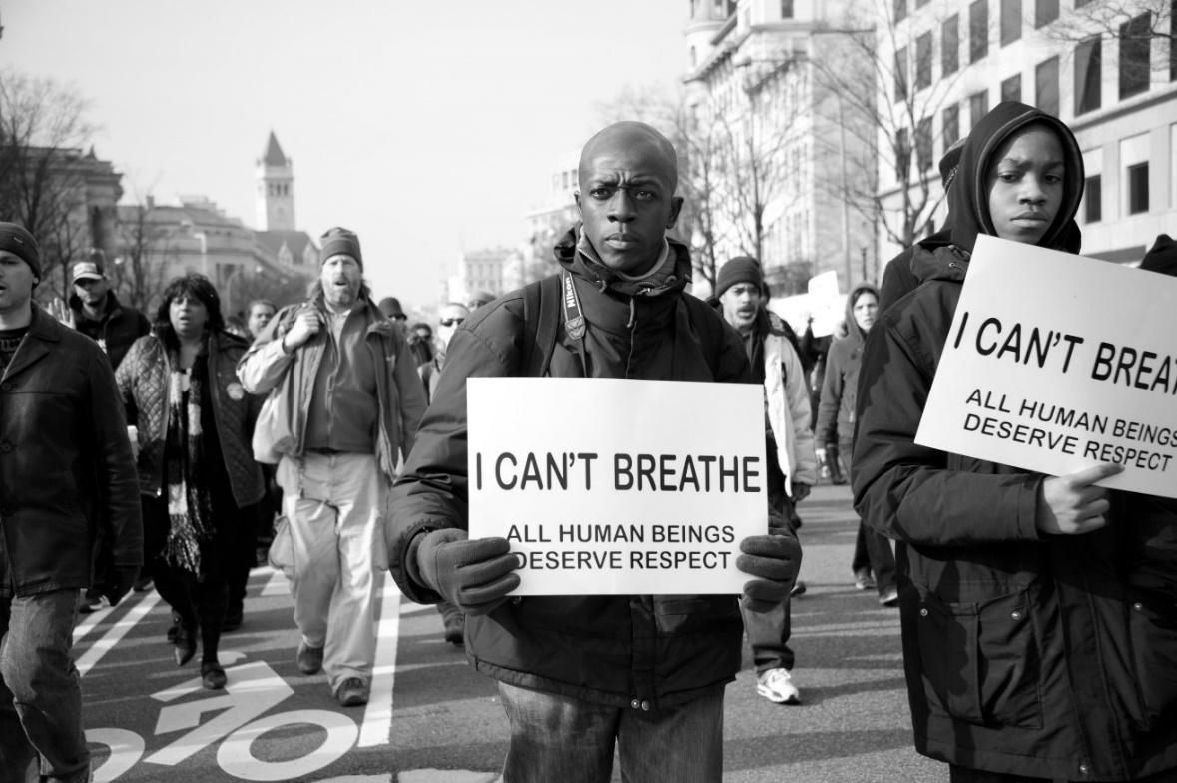
Selma, Alabama 1965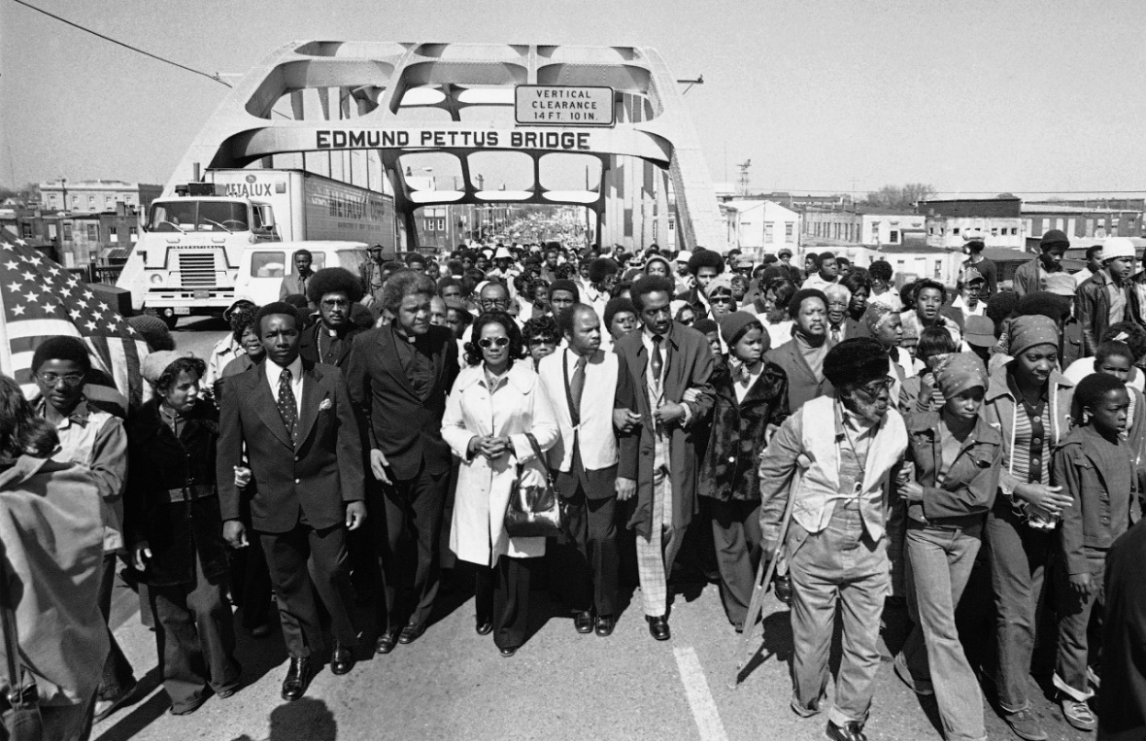
______________________________________________________
Source G
https://whataretheylearning.com/about/ 2022
The Problem
With coronavirus-trigged "distance learning," parents are discovering what has been going on behind closed doors for years: schools routinely assign curriculum that aggressively pushes points of view on contemporaneous political debates, and encourages students to adopt the belief that they are oppressed and powerless -- even if they previously operated under the assumption that they were happy and free.
The use of government money to push a political agenda is a shocking breach, and no person -- even if you agree with the ideas -- should support it.
It has often gone undetected because American schools are run by 13,000 independent school systems. To whom do you turn when someone takes advantage of their access to your child to teach non-academic ideas that are at best, political, and at worst, factually wrong and even psychologically devastating?
The ideology most commonly being pushed, related to "equity" (defined as equal outcomes) and "critical race theory," is not a preference for the Democratic party over the Republican one, but rather something closer to nihilism -- that American children are living under a tyrannical capitalistic regime. As bizarre as that sounds, it's happening in nearly every school district, from rural to urban, and is funded by our own government.
Dressed up in vague but pleasant-sounding words, these initiatives sometimes pass unnoticed in principle. But once implemented, they are nothing like what residents thought -- or would be OK with. They are not "racial sensitivity training" or "diversity training." You have to see it to believe it.
America’s most important institution has been taken over by people espousing cynical, pessimistic and divisive beliefs that almost no one outside a group of professional activists actually believes.
Millions of parents across America are hoping someone will step up. But in small towns everywhere, that person may have to be you. This website allows you to browse problematic curriculum being assigned across the country, and anonymously upload your own examples from your child's school.
These people push this curriculum on children precisely because they are some of the only people who don't know any better -- or don't have the authority -- to push back. Adults seem to know what they're doing is wrong, and when it sees the light of day, frequently recoil. This site facilitates that transparency.
If it's being taught to our children as fact, we have a right to see it. And you can play a part.
What's covered
This site covers K-12 schools, both public and private. For private schools, browse or enter your tip using the school district they're physically located in.
Because "woke" indoctrination is also increasingly entering the workplace, we've now added the ability to add tips about companies, too, under the "Woke Corporations" menu.
For colleges, please use the Legal Insurrection Foundation's criticalrace.org.
To get resources on how you can get involved and fight back, please see Parents Defending Education.
About the site
This is a crowd-sourced site created by Luke Rosiak, an investigative journalist and data analyst in the Washington, D.C. area who has written about the impact of "Equity" on schools across the country.
______________________________________________________
Source H
Marsha Blackburn, “Why is Critical Race Theory Dangerous For Our Kids?”, 2021
For months, parents have raised the alarm about the left’s effort to brainwash our children by injecting Critical Race Theory (CRT) into public school curriculum. One Tennessee mom recently warned Williamson County parents that her seven-year-old daughter came home from school saying, “I’m ashamed that I’m White.” Her daughter asked, “Is there something wrong with me? Why am I hated so much?” This reaction is reason enough to start asking questions, but those who have yet to investigate the tenets of CRT will be shocked to know that this child’s distress was the desired result of her lessons. If left unchecked, this mental and emotional trauma will worm its way into every classroom in America.
Although promoted as “anti-racist” civil rights education, CRT actively encourages discrimination. At its core, CRT segregates people into two main categories: oppressors or victims. The calculation is based solely on skin color. The tenets of CRT stretch far beyond the humanities. In some classrooms in Oregon and California, students operate under the understanding that “finding the right answer” in mathematics is racist. “Right” and “wrong” answers are deemed a product of white supremacy. The woke gymnastics required to reach such a conclusion would be amusing if this destructive ideology didn’t pose such a danger to education in America.
We can all agree that racism and discrimination are wrong and have no place in the classroom—but neither does racially motivated propaganda. In the U.S. Senate, I’ve been leading the charge for true equality in the classroom. I led legislation prohibiting federal funding of the “1619 Project,” which reframes American history in terms of racial conflict and oppression. I also joined my Senate colleagues in demanding that Critical Race Theory’s prejudicial influence be kept out of K–12 classrooms.
Many on the left have tried to dismiss this as a political non-issue, but here in Tennessee, we see opposition to CRT is coming straight from parents and educators. In response, the Tennessee State Legislature passed and Governor Bill Lee signed a bill banning CRT in schools. Still, we must continue to stand firm at a local level. Children should not be forced to endure this latest round of revisionist history, but it will take more than letters and legislation to keep CRT out of the classroom. Parents need to keep showing up to school board meetings and reporting discriminatory conduct.
The last thing educators should be doing is encouraging our children to be ashamed of the color of their skin. That same Williamson County mom who warned about the dangers of CRT was left with no choice but to put her seven-year-old in therapy. Why? “She is depressed. She doesn’t want to go to school.” While parents struggle to help their children manage the mental and emotional damage inflicted by this dangerous ideology, the left will continue to re-write our education system to fit their woke agenda—and they won’t stop until CRT is in every classroom in America. I will gladly stand with Tennessee parents to demand an end to this latest, unhinged attempt to brainwash our nation’s children.
______________________________________________________
Source I
Dina Smeltz, “Republican Views on Racial Inequality Starkly Contrast Those of Democrats”, The Chicago Council on Global Affairs, 2020

Half of US public rates racial inequality a critical threat
- One out of two Americans (51%) says that racial inequality in the United States is a critical threat to the country, and only 31 percent of Americans feel that the US government is handling the issue effectively.
- There are large partisan divides on the magnitude of the threat posed by inequality. Nearly three-quarters of Democrats (73%) say that racial inequality is a critical threat to the country, on par with climate change (75%) and just below the threat they find most critical, the coronavirus pandemic (87%). Eight in ten say the US government is doing an ineffective job on the issue of racial inequality.
- By contrast, just 23 percent of Republicans say that racial inequality is a critical threat. For GOP supporters, racial inequality, climate change (21%) and economic inequality (21%) are the three items rated the least critical of the 15 items presented. Half (49%) say the US government is doing an effective job in addressing racial inequality.
- As might be expected, there are also large racial differences in responses. Nearly nine in ten black Americans (86%) and a smaller majority of Hispanic Americans (58%) consider racial inequality a critical threat compared to 42 percent of white Americans.
Six in ten consider domestic violent extremism a critical threat
- A majority of Americans (57%) consider domestic violent extremism a critical threat, a higher percentage than think the same of international terrorism (54%). Yet only 32 percent of Americans think the government is doing an effective job handling domestic violent extremism, compared to 55 percent who think it is handling terrorism effectively.
- Six in ten Democrats say that domestic violent extremism is a critical threat (58%); they likely have white nationalist groups in mind.
- Six in ten Republicans also consider domestic violent extremism a critical threat, perhaps interpreting this to also include individuals affiliating with the anti-fascist movement (Antifa) and/or looters and vandals who took advantage of the disorder during the protests.
- About six in ten across all races agree that domestic violent extremism is a critical threat (58% of black Americans, 60% of Hispanic Americans and 56% of white Americans).
Republicans more likely to favor use of force against protests
- Democrats (85%) are far more likely to say they followed the news about the protests after the death of George Floyd than are Republicans (51%). Only 17 percent of Democrats favor using US troops to suppress protests, and 38 percent favor using force to quell riots, looting, and vandals.
- Solid majorities of Republicans support the use of force to suppress both protests in the United States (59%) and riots, looting, and vandalism (83%). Half (50%) also support increasing federal budget expenditures to state and local police and law enforcement.
Methodology
This analysis is based on data from the 2020 Chicago Council Survey of the American public on foreign policy, a project of the Lester Crown Center on US Foreign Policy. The 2020 Chicago Council Survey was conducted July 2-19, 2020 by IPSOS using their large-scale nationwide online research panel, KnowledgePanel, among a weighted national sample of 2,111 adults, 18 years of age or older, living in all 50 US states and the District of Columbia. The margin of sampling error for the full sample is ±2.3 percentage points, including a design effect of 1.2056. The margin of error is higher for partisan subgroups or for partial-sample items.
Partisan identification is based on respondents' answer to a standard partisan self-identification question: “Generally speaking, do you think of yourself as a Republican, a Democrat, an Independent, or what?”

