FAMILY Engagment Team

Team Members
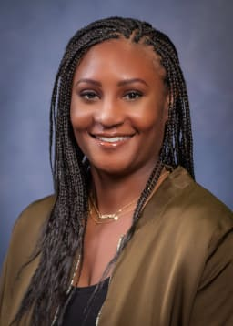

KISA HENDRICKSON, CHIEF ENGAGEMENT AND PARTNERSHIP OFFICER
Email: kisa.hendrickson@highlineschools.org

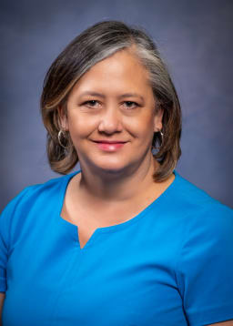

LITA O'DONNELL, DIRECTOR OF FAMILY & COMMUNITY PARTNERSHIPS
Email: Lolita.ODonnell@highlineschools.org

LILLY CASTRO-ACOSTA, FAMILY ENGAGEMENT SPECIALIST
Email: lilly.castro-acosta@highlineschools.org
Supporting Schools: Cedarhurst, Mount View, Shorewood, Southern Heights

REBECA PINZON, FAMILY ENGAGEMENT SPECIALIST
Email: rebeca.pinzon@highlineschools.org
Supporting Schools: Bow Lake, McMicken Heights, Gregory Heights, Seahurst
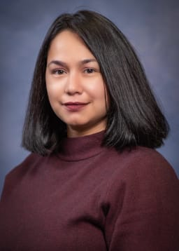

ROCIO CEJA, FAMILY ENGAGEMENT SPECIALIST
Email: rocio.ceja@highlineschools.org
Supporting Schools: Beverly Park, Hazel Valley, Hilltop, White Center

ROSIE SANTIAGO, FAMILY ENGAGEMENT SPECIALIST
Email: Maria.Santiago@highlineschools.org
Supporting Schools: Des Moines, Madrona, Midway, Parkside

ARONE ANDU, FAMILY ENGAGEMENT SPECIALIST
Email: Arone.andu@highlineschools.org
Supporting Schools: Big Picture, Choice, Maritime, New Start, Raisbeck Aviation, Virtual Academy

CARESS PINA, FAMILY ENGAGEMENT SPECIALIST
Email: Caress.pina@highlineschools.org
Supporting Schools: Cascade, Chinook, Glacier, Pacific, Sylvester
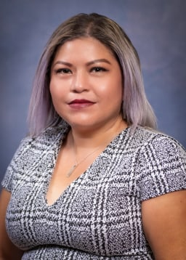

ROSA MANRIQUEZ, FAMILY ENGAGEMENT SPECIALIST
Email: rosa.manriquez@highlineschools.org
Supporting Schools: Evergreen, Highline, Mount Rainier, Tyee

